Relational Algebra

Given the following set of tables:
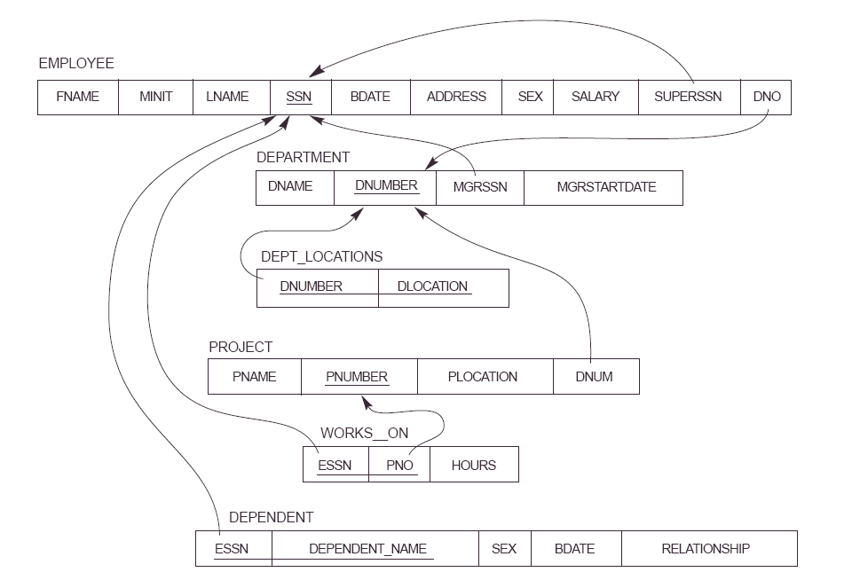

You can use the Relational Algebra Calculator to test your code
https://dbis-uibk.github.io/relax/calc.htm

(1) Retrieve the names (fname,lname) of employees who work more than 10 hours per week on the 'ASTU' project. (“ASTU” is project name.)

π _{fname, lname} σ employee.ssn = works_on.ssn and works_on.pno = project.pno and Hours > 10 and pname = 'ASTU' ( ( employee ⨯ works_on ) ⨯ project )

(2) Retrieve the names (fname, lname) of all employees who work on at least one project.

π _{fname, lname} σ employee.ssn = works_on.ssn and works_on.pno ≥ 1 ( ( employee ⨯ works_on ) ⨯ project )

(3) Retrieve the locations of “CPE” department. (“CPE” is department name).

π _{dlocation} σ dept_locations.dnum = department.dnum and dname = 'CPE' ( dept_locations ⨯ department )

(4) Find the name (fname,lname) of the direct supervisor of “Mary Smith”. (“Mary Smith” is an employee).

π e2.fname, e2.lname (σ e1.superssn = e2.ssn and e1.fname = 'Mary' ∧ e1.lname = 'Smith' ((ρ e1 employee) ⨯ (ρ e2 employee)))
5) Draw the query tree for question #4

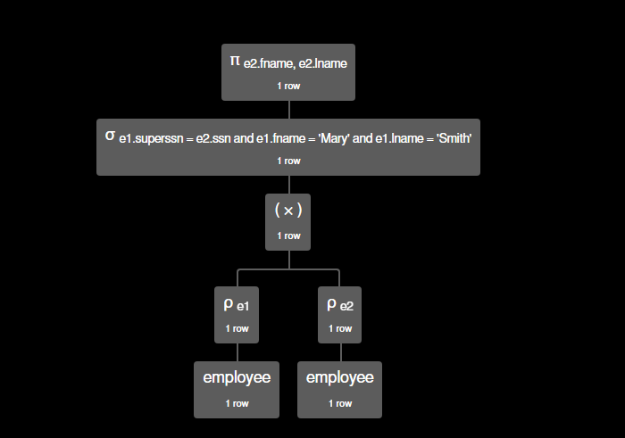

Here is some sample code code that shows how to create relations with data that can be used in the relational algebra editor. Change the data and code to fit your database

group: disease

patient = {
ssn, fname, age

1, 'a', 30
3, 'b', 22
4, 'c', 33
5, 'd', 44
6, 'e', 25
}

patientdisease = {
ssn, id

1, 11
2, 22
1, 12
}

disease= {
id, descr

11, 'malaria'
22, 'flu'
33, 'cold'
}

